In AWS console search RDS in that click databases->Create database-> select the standard create option-> select engine type as MySQL. In templates choose the free tier template or relevant template.

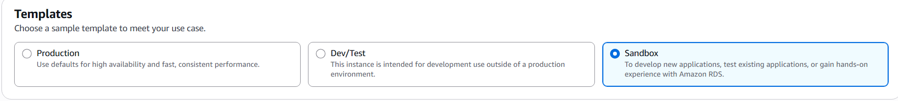

**DB instance identifier-** employee-db  
give the credentials

keep the defaults for all of these other sections here.